Knowledge-Based Systems

How are Knowledge-Based and Expert Systems similar to Decision Support Systems?

* They are both based on **relational** **information.**

How are Knowledge-Based and Expert Systems different from Decision Support Systems?

|  |  |
| --- | --- |
| Decision Support  Systems | Knowledge-Based and  Expert Systems |
| * quantitative (numbers) * model-based * Y = ***f*** (X) | * qualitative (text) * rule-based * when facing …, do … |

Knowledge-Based and Expert Systems are the follow-up to Decision Support Systems?

* Decision Support Systems: Which course of action is the best?
* Knowledge-Based and Expert Systems: How to implement the above course of action?
* Decision Support Systems: Buying a hybrid car is worth it when the price of gas > $6/gallon
* Knowledge-Based and Expert Systems: To buy a hybrid car, follow these steps: …………

What types of things do we know?

* We know that/when/who/where/what 🡺 Factual Knowledge 🡺 Information
* We know how-to 🡺 Procedural Knowledge 🡺 Skill/Competence
* We know why 🡺 Explanatory Knowledge 🡺 Understanding

Call Taken: 7/17/2003, 12:06:00 PM  
Work Started: 7/17/2003, 3:30:00 PM  
Problem Solved: 7/17/2003, 4:15:00 PM  
  
Problem Category: Lecturn - PB134  
Short Description: Adobe Acrobat 6 does not display images.  
Progress: Assigned to Rickl 7/17/2003  
  
Solution Details: Chris was working on this lecturn computer to troubleshoot the problem. We found that Acrobat Reader 6 does not display large images in the document by default. To resolve this problem, edit the program preferences by clicking "Edit / Preferences / Page Display" and check the box labeled "*Display large images*". Acrobat Reader will then display all images in the document.

Tacit (intuitive) Knowledge

Explicit (structured) Knowledge

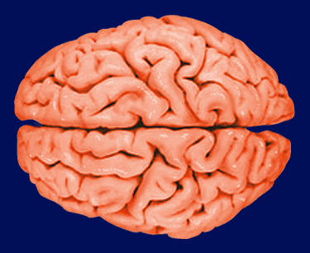

Knowledge-Base

(Free-Form Text)

** search**

**knowledge**

**response**

Expert/

Specialist

User

**[](http://www.google.com/url?sa=i&rct=j&q=dart+throwing&source=images&cd=&cad=rja&docid=zEZ-NpAcy7vo1M&tbnid=dFmdDHAvXzrHQM:&ved=0CAUQjRw&url=http%3A%2F%2Fwww.dartworld.com%2Fanswers.html&ei=sWtHUdzTBsuwqwG9ioDoAQ&bvm=bv.43828540,d.aWc&psig=AFQjCNFwAa2U4P1kbyiO4m6dAo_pSI0TTw&ust=1363721478661321)**

Experience

**Textbook (pages 89-90)**

creating knowledge

capturing and storing knowledge

disseminating knowledge

**The Mother of Knowledge Management:** [Julia Child](http://en.wikipedia.org/wiki/Julia_child).

Read enough to figure out her role in knowledge management.